**Difficult: Multiple Year Stock Data 2016**

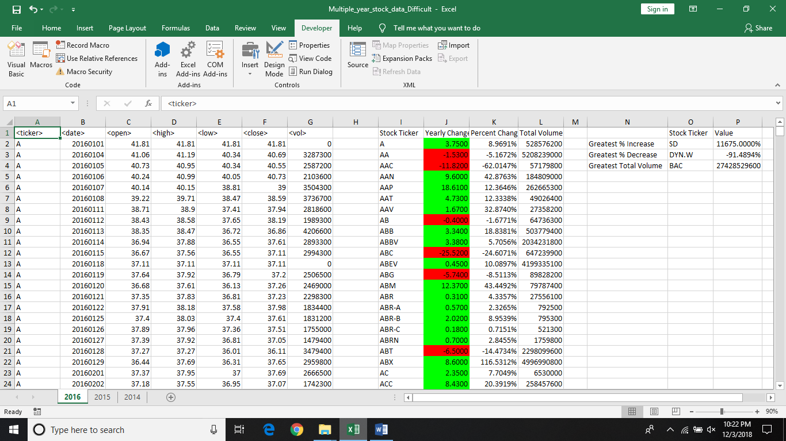

**Difficult: Multiple Year Stock Data 2015**



**Difficult: Multiple Year Stock Data 2014**

